Test results for exercise 6a:

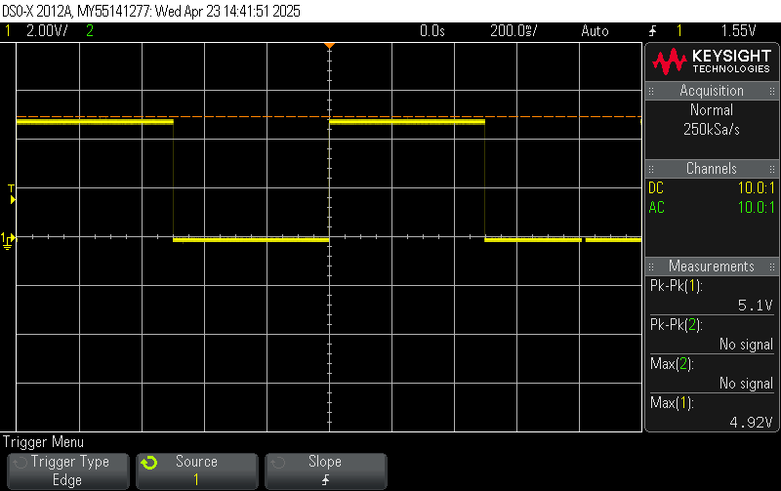

Screenshot of oscilloscope view from the program. As can be seen, works correctly

Exercise 6b:

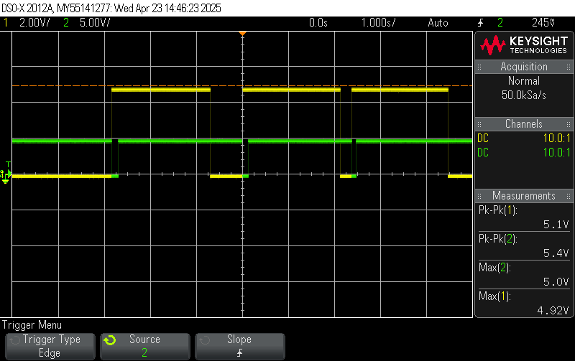

The program was configured to activate the LED on the falling edge of button 1/PD4. C1 in yellow represents the LED, and C2 in green the button signal.

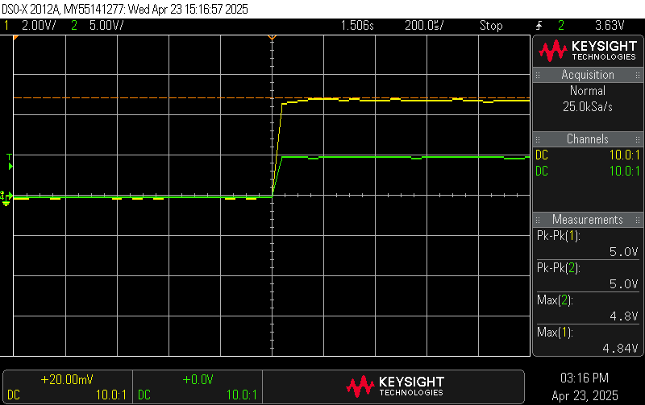

From zooming in, the LED activation has microseconds of delay compared to the button press, making it very fast.

Exercise 6c:

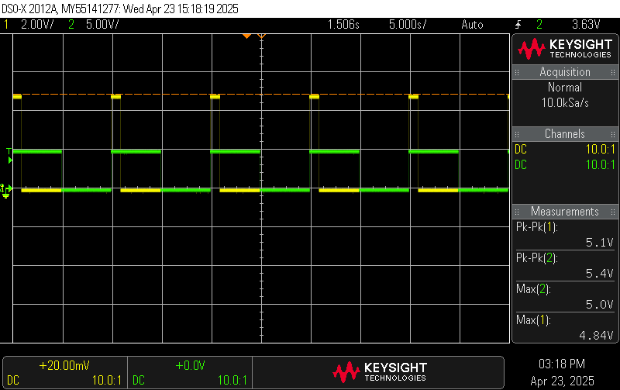

I actually set the function generator to trigger the interrupt every 10s :) but outside of that the program works correctly. The trigger is on INT0/PD2.

Exercise 6d:

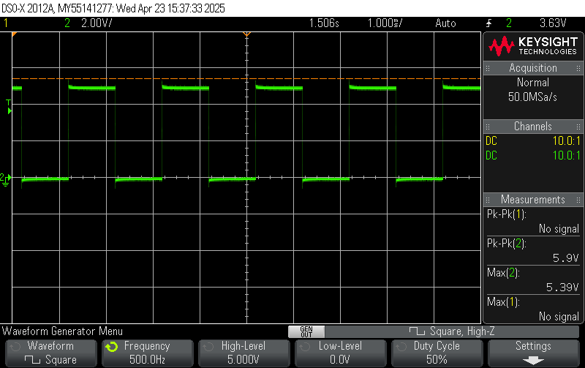

The image shows the possible frequency the Arduino program can measure during testing. After that, the output step over UART along with the interrupts from the timer take too long for the output to be visible. This could be optimized by using a full 1s timer instead of a 1000x1ms like the one set up.